**Practical 11**

**Questions**

**4 April 2022**

1. Find the propensity of alpha helices using the following sequence and secondary structure assignments.

Sequence: LGASGIAAFAFGSTAILIILFNMAAEVHFDPLQFFRQFFWLGLYPPKAQY

Sec. str: XHHHHHHHHHHHHHHHHHHHHHHHHHXXXXXXXXXXXXXXXXXXXXXXXX

Sequence: GMGIPPLHDGGWWLMAGLFMTLSLGSWWIRVYSRARALGLGTHIAWNFAA

Sec. str: XXXXXXXXXXHHHHHHHHHHHHHHHHHHHHHHHHHHHHHHXXHHHHHHHH

Sequence: AIFFVLCIGCIHPTLVGSWSEGVPFGIWPHIDWLTAFSIRYGNFYYCPWH

Sec. str: HHHHHHHHHXXXXXXXXXXXXXXXXXXXXXXXXXXXXXXXXXXXXXXHHH

Sequence: GFSIGFAYGCGLLFAAHGATILAVARFGGDREIEQITDRGTAVERAALFW

Sec. str: HHHHHHHHHHHHHHHHHHHHHHHXXXXXXXXXXXXXXXXXXXXXXXXXXX

2. Find the propensity of alpha helices manually for the sequence in question 1.

3. Using the rules for helices and strands, identify the helical and strand segments in the following sequence

KVFGRCELAAAMKRHGLDNYRGYSLGNWVCAAKFESNFNTQATNRNTDGSTDYGILQINSRWWCNDGRTPGSRNLCNIPCSALLSSDITASVNCAKKIVSDGNGMNAWVAWRNRCKGTDVQAWIRGCRL

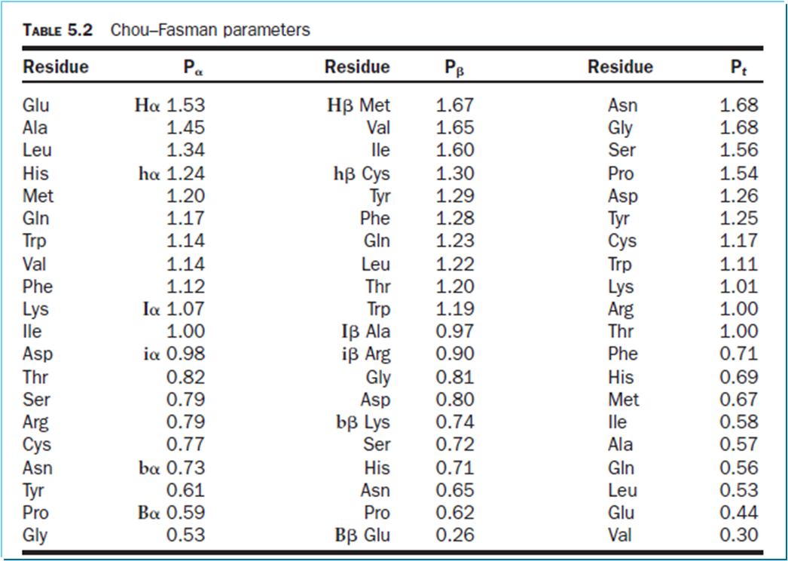

Hint: **Helix**: Assign 1 for Hα and hα; 0.5 for Iα; 0 for iα; -1 for Bα and bα; identify 6-residue segments with score more than or equal to 4; extend it until the actual value (Table 5.2) for last four residues is less than 4. Continue the search.

**Strand**:

Assign 1 for Hβ and hβ; 0.5 for Iβ; 0 for iβ; -1 for Bβ and bβ; identify 5-residue segments with score more than or equal to 3; extend it until the actual value for the last three residues is less than 3.

For conflicting situation: compare the values and assign the secondary structure based on the highest value

4. Verify one of the helical and strand segments, manually.

**Deadline: 10 April 2022**